When we start a container its always in interative mode
sudo docker container run --name Lau1 nginx
sudo systemctl status docker
sudo docker container start -i myOS
sudo docker inspect Jabra
stopped container don't have IP can run inspect and check

Logs
sudo docker container run -d mysql
It ran and exitted. What went wrong we can check using docker command for logs
sudo docker logs 11f1
Now we know we need to pass db password as env variables in command for mySQL
You need to specify one of the following:
- MYSQL_ROOT_PASSWORD
- MYSQL_ALLOW_EMPTY_PASSWORD
- MYSQL_RANDOM_ROOT_PASSWORD

passing enviornment variables
sudo docker container run -d --name mydb -e MYSQL_ROOT_PASSWORD=password mysql

sudo docker stats
sudo docker container run -d --name newngix --memory 500M nginx

sudo docker top newngix

sudo docker rename boom1 choom

sudo docker rm choom

when the host machine restarts the docker services are restarted
There is a restart policy which determines weather the container will restart or not

restart policy can be set during run(creating container)
No (default)
On-failure (when exit code is non zero)
always (will restart even if the container was stop )
stopped (will restart only if the container was running at the time docker was restarted )

sudo docker container run -d --name pappu --restart always nginx
sudo docker container run -d --name pappa nginx

copy files
touch testfile
sudo docker cp testfile pappu:/tmp
sudo docker exec pappu ls -al /tmp

can inspect images

<--------Images Layers------->
An image contains multiple layers
image path
sudo ls -al /var/lib/docker/image/overlay2/imagedb/content/sha256
layes path. Layers encrypted by sha256
sudo ls -al /var/lib/docker/image/overlay2/layerdb/sha256
layers are immutable
when we create an image it adds a writable layer on top layers where we can modify the image
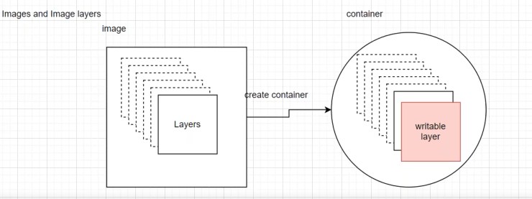same layer can be used by multiple images

<------push images to docker--------->
docker login
docker tag ubuntu justamitsaha/testImage
docker push amit/registry
docker commit -m "myownimage" ubuntu amit/registry

manually start docker
docker container run -it --name myOS ubuntu /bin/bash
or
docker container run -it --name myOS ubuntu
apt-get update
apt-get install git

docker commit -m "myOs" myOS justamitsaha/testOS

